Lab 2
Embedded System

From
Name::M Husnain Khalid
Roll No: 22l-6286

Instructor:Muhammad Ahmad

EXPERIMENT 2
INTRODUCTION TO TIVA C SERIES LAUNCHPAD AND CONFIGURING KEIL μVISION4 FOR FIRST PROJECT

EXERCISE - 1:
Run blinky project from C:\ti\TivaWare_C_Series-2.1.4.178\examples\boards\ek-
tm4c123gxl\blinky project to your board. Open any of its .bin file and upload it to your controller. It is a very simple example that blinks the on-board LED using direct register access.
Please give your code for solving the above question in the space below and paste the screen shot of the output:

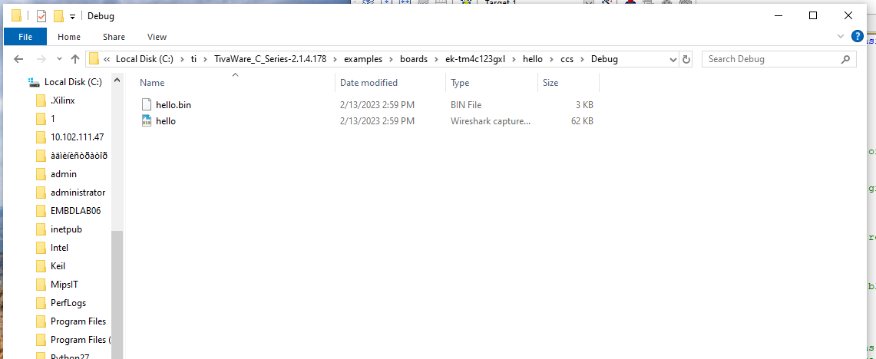
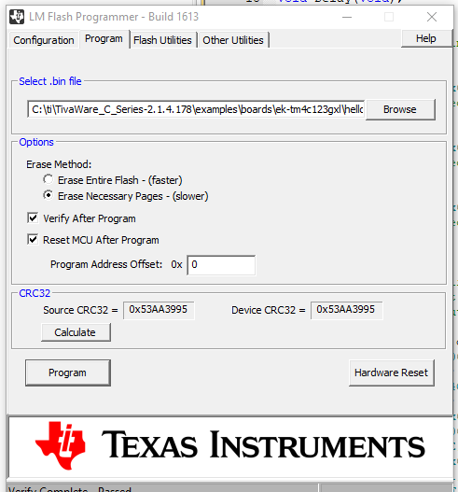

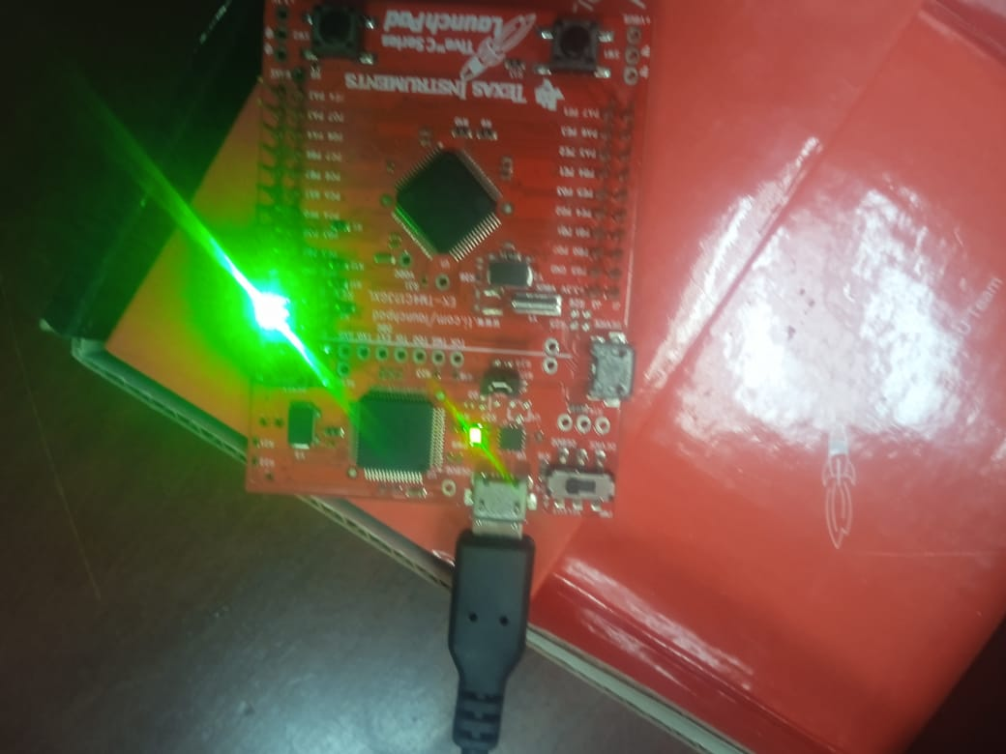
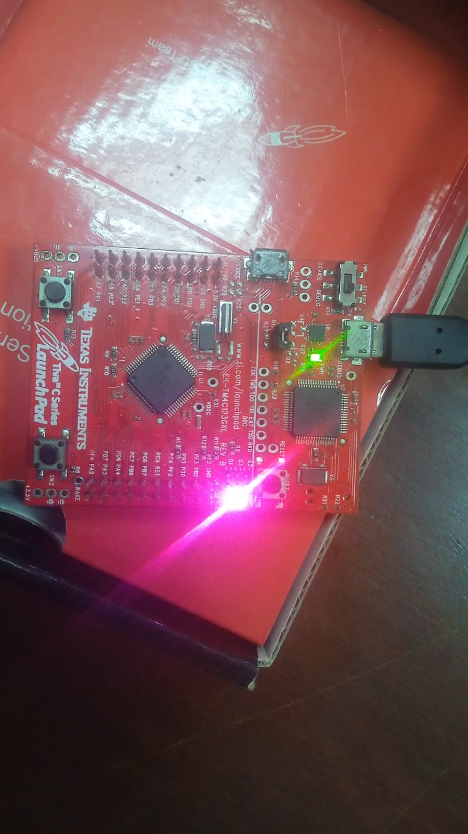

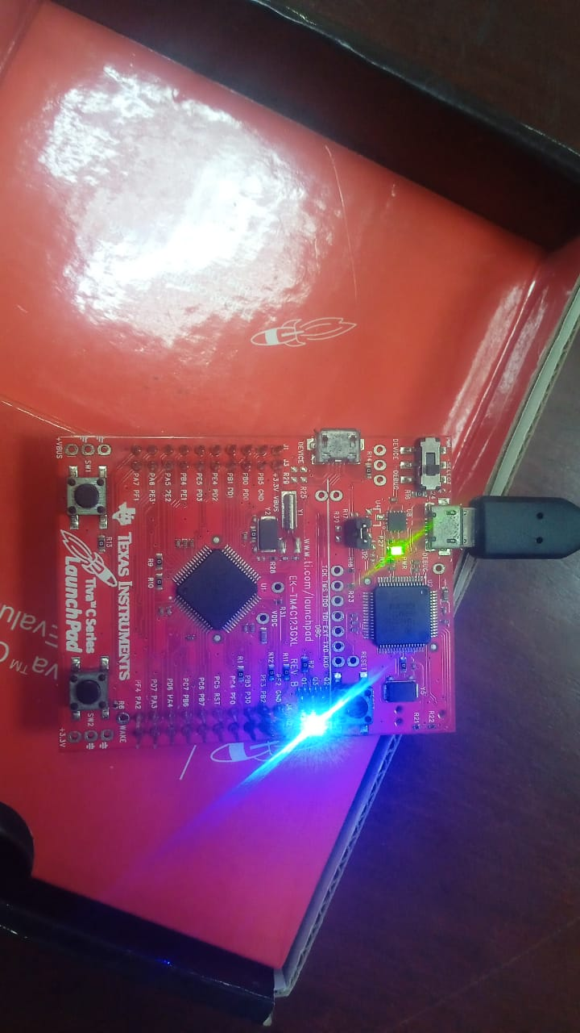
EXERCISE – 2:
Run hello project from C:\ti\TivaWare_C_Series-2.1.4.178\examples\boards\ek- tm4c123gxl\hello. Open any of its .bin file and upload it to your controller. It is a very simple "hello world" example. It simply displays "Hello World!" on the UART and is a starting point for more complicated applications. UARTO, connected to the Virtual Serial Port (running at 115,200 baud rate), is used to display messages from this application. For observing virtual port output use TeraTerm.
Using TeraTerm
a. Install Tera Term utility by clicking teraterm.exe
b. Select I agreed and click next.
c. Keep the default path for application to install and click next
d. Install the rest of application keeping the default settings
e. Launch Tera Term and select serial connection
f. Open setup for serial
g. Select the desired baud rate
h. Connect LaunchPad and press resetbutton
Please give your code for solving the above question in the space below and paste the screen shot of the output:

